Report

Made a dashboard for the analysis

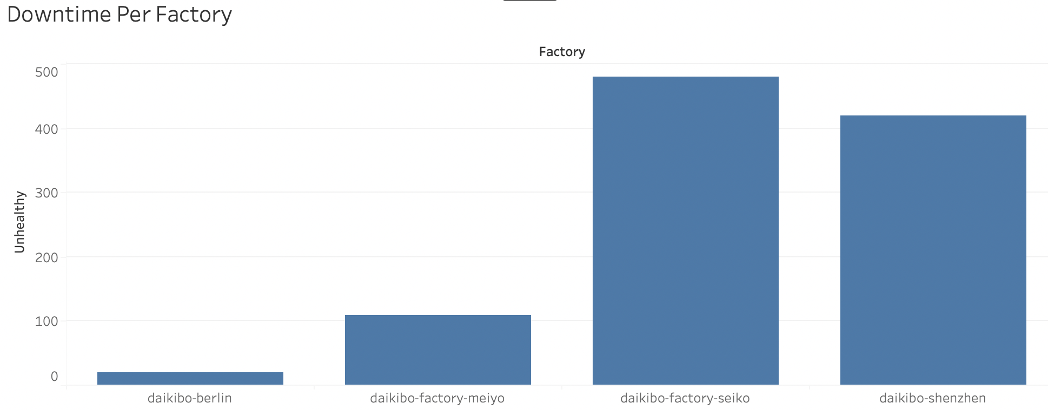

When I click the factory, I can inspect Downtime Per Machine for each factory.

Question: what factory has the most down time

Answer: Seiko factory has the highest down time

And the detail of the Seiko factory looks like this.

